**Team ID:PNT2022TMID47880**

**Image Processing:**

Image Processing is a method to convert an image into digit form and perform some operations on it, in order to get an enhanced image or to extract some useful information form it.

It is a type of signal Dispensation in which input is image,like video frames or photograph and output may be image or characteristics associated with that image

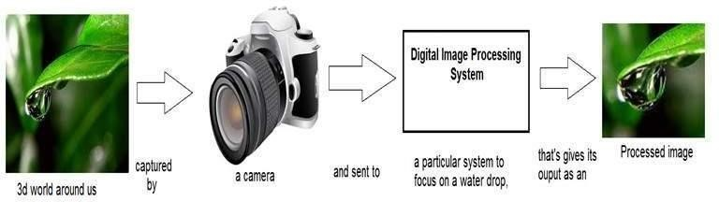

**Digital Image:**

A Digital image is a representation of a two-dimensional image as a finite set of digital values, called picture elements or pixels

Pixel Value Typically Represent graylevels,colors,heights,opacities etc

**Common Image formats includes:**

1 sample per point(B&W or Grayscales)

1. samples per point(Red,Green, and Blue)
2. samples per point(Red,Green,Blue, and "Alpha")

**Image Processing in Deep Learning:**

Image processing is an play in major role in Computer Vision.Computer Vision is an one of the part in Artificial Intelligences.Computer Vision can interact with a image data types such like Image Classification,objectlocalization,objectDetection,Segmentation etc

In nature of Computer vision using an Deep Learning Algorithms,OpenCV,Pose Estimation Python Libraries etc, In Deep Learning it has been working on Neural Network which can interact and Extract the feature from the image and creating the Deep Learning Model it requires to build with high Accuracy and Less in Model Size can reduce the Computation power of the System,Mobile,cloud interface

**Case Study of the Model Building in Deep Learning:**

In Training Deep Learning Model requires an high image Dataset to train an Deep Learning Model.But in the case of low or Small dataset can convert into the Huge dataset by using the Image processing Techniques.Due to increasing the Image dataset by Annotating the image

**Augmentation:**

Deep networks need large amount of training data to achieve good performance. To build a powerful image classifier using tiny training data, image augmentation is usually required to boost the performance of deep networks. Image augmentation artificially creates training images through different ways of processing or combination of multiple processing, such as random rotation, shifts, shear and flips, etc.

In Augmentation we can Increase the images in the dataset by using some combination technique which can help to increase the accuracy of the Deep learning Models

Some Example for Augmentation techniques are used in this Projects:

Rotating the Image Zoom the image crop the image

Image can Convert 3 channel to grayscale Image shear the image in various angle as it Possible

**Annotation:**

Data annotation is the categorization and labeling of data for AI applications**.** Training data must be properly categorized and annotated for a specific use case. With high-quality, human-powered data annotation, companies can build and improve AI implementations

Image annotation for deep learning is mainly done for object detection with more precision. 3D Cuboid Annotation, Semantic Segmentation, and polygon annotation are used to annotate the images using the right tool to make the objects well-defined in the image for neural network analysis in deep learning.

**Team ID:PNT2022TMID47880**